SUMMARIZATION OF

TEXT FILE ->TEXT FILE

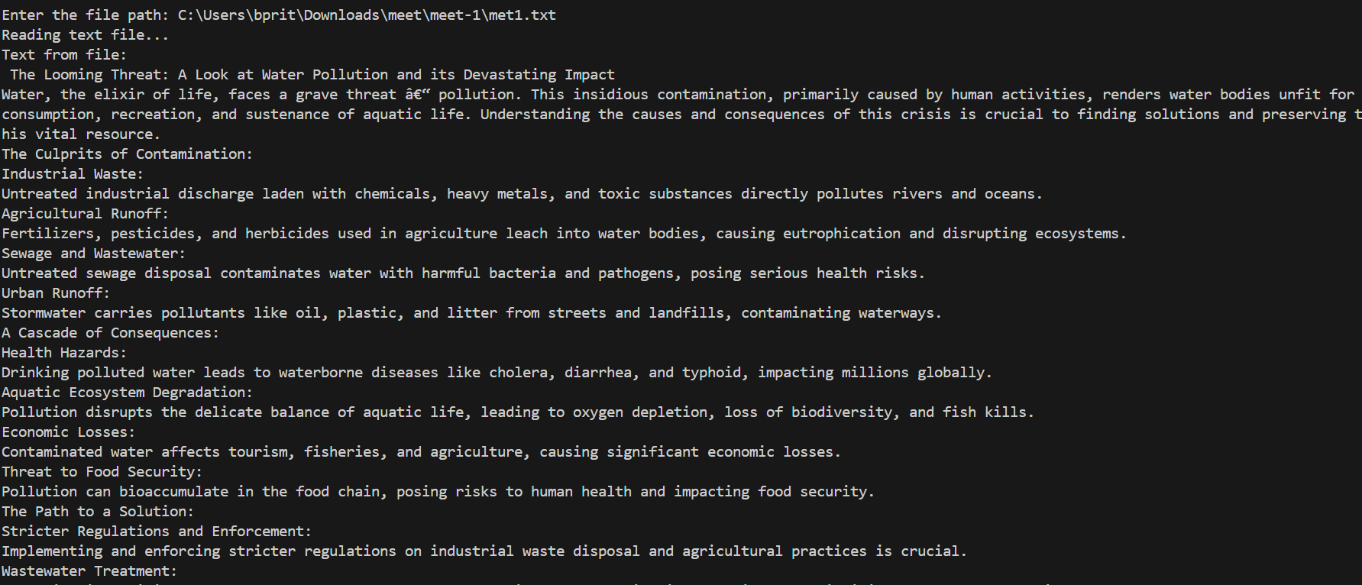

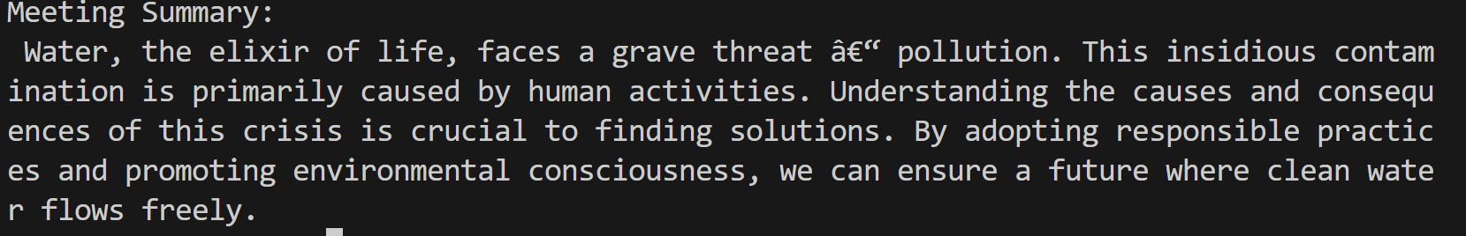

SUMMARIZATION OF

AUDIO->TEXT(.WAV-TXT)

